**AWS ECR**

Follow the below commands to install docker in amazon ec2 instance

sudo yum update –y

sudo yum install docker

sudo service docker start

sudo usermod -a -G docker ec2-user

Note-Add the ec2-user to the docker group so you can execute Docker commands without using sudo.

Create a Docker image

1. Create a file called Dockerfile.

touch Dockerfile

1. Edit the Dockerfile you just created and add the following content.

FROM public.ecr.aws/amazonlinux/amazonlinux:latest

# Install dependencies

RUN yum update -y && \

yum install -y httpd

# Install apache and write hello world message

RUN echo 'Hello World!' > /var/www/html/index.html

# Configure apache

RUN echo 'mkdir -p /var/run/httpd' >> /root/run_apache.sh && \

echo 'mkdir -p /var/lock/httpd' >> /root/run_apache.sh && \

echo '/usr/sbin/httpd -D FOREGROUND' >> /root/run_apache.sh && \

chmod 755 /root/run_apache.sh

EXPOSE 80

CMD /root/run_apache.sh

1. Build the Docker image from your Dockerfile.

docker build -t hello-world .

1. List your container image.

docker images --filter reference=hello-world

1. Run the newly built image. The -p 80:80 option maps the exposed port 80 on the container to port 80 on the host system.

docker run -t -i -p 80:80 hello-world

1. Open a browser and point to the server that is running Docker and hosting your container.
2. Push your image to Amazon Elastic Container Registry

Creating ec2linux2 instance for creating docker image push it to registry

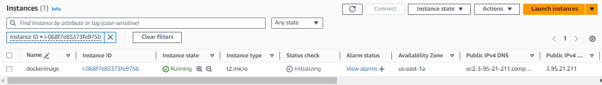

Tag the image to ecr

docker tag hello-world 088285363738.dkr.ecr.us-east-1.amazonaws.com/httpdserver

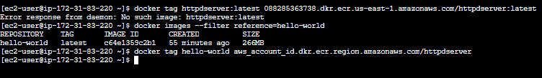

Push

docker push 088285363738.dkr.ecr.us-east-1.amazonaws.com/httpdserver